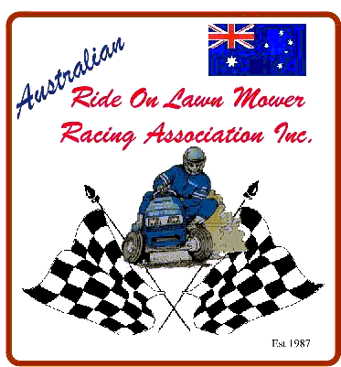
Australian Ride On Lawn Mower Racing Association Inc.
A0040218E
ABN 23 795 075 312

Minor Release Form

Warning: This is an important document, which affects your legal rights and obligations.
Read it carefully. Do not sign it unless you are satisfied that you understand it.

I/We, __________________________________________________________
Parent/Guardian

Of __________________________________________________________
Enter your complete address including postcode

DO HERBY ACKNOWLEDGE AND DECLARE THAT –

1. I/We are the parent/legal guardian’s of_______________________________
who has requested permission to participate in events conducted by the Australian Ride On Lawn Mower Racing Association Inc., as arranged from time to time.

2. The above-named was born on ____/____/____ and has not yet reached the age of 18 years.

3. I/We are fully aware of the implications and dangers involved in the sport of Lawn Mower Racing.

4. I/WE have read the Rules of the Australian Ride on Lawn Mower Racing Association Inc.,
and I/We understand them and agree to abide by them

5. I/We consent to our child participating in these events.

6. In consideration of our child being accepted as a participant I/We HERBY INDEMNIFY the organisers, land owners, the Australian Ride On Lawn Mower Racing Association Inc. and their respective representatives in the same manner and to the same effect as if I/We were entrant/s.

____________________________________ ______/______/_____
Signature Date

NB: All alterations and deletions where appropriate should be initialled by the signatory. This practice is recognised as further proof that the signatory has read this document in its entirety and understands its contents.

