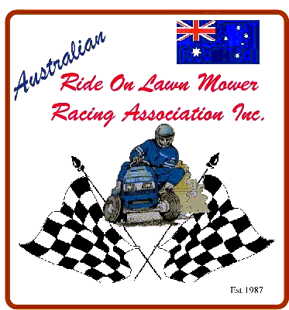
Pit Crew/Guest Mower #______ Class_______
Australian Ride On Lawn Mower Racing Association Inc. A0040218E
ABN 23 795 075 312
Contract to Participate in Competition an/or Practice Events
Warning: This is an important document, which affects your legal rights and obligations.
Read it carefully. Do not sign it unless you are satisfied that you understand it.
I, _______________________________________________________________
Enter your full name
Of________________________________________________________________
Enter your complete address including postcode
HEREBY AGREE with the Australian Ride On Lawn Mower Racing Association Inc., and all other individuals, organizations and bodies corporate whose names appear in Schedule 1 that I am by agreement entitled to participate in the Lawn Mower Racing activity listed in Schedule 2 at the venue listed at Schedule 3 on the terms and conditions set out in this document.
Acknowledgement of Risks, Dangers and Obligations.
I ACKNOWLEDGE that the sport of lawn mower racing is dangerous and that by engaging in the sport and participating in (the Meeting) I take and am exposed to certain risks and dangers, and am under certain obligations as follows -
(a) That I may be injured, physically or mentally, and I may be killed;
(b) That my machinery or equipment may be lost, damaged or destroyed;
(c) That other competitors may ride dangerously and with lack of skill;
(d) That track or event conditions may be hazardous and may vary without warning or predictability;
(e) That organizers, officials, landowners, track operators and any agents or representatives of those in charge of meetings are frequently obliged to make decisions under pressure of time and/or events;
(f) That any policy of insurance of or in respect of my life or physical or mental health may be avoided;
(g) That there may be no or inadequate facilities for treatment or transport of me if I am injured;
(h) That I have an obligation to myself and to others to compete safely and within the Rules of Competition.
Indemnity Given to Organisers
IN CONSIDERATION of the acceptance of me as an entrant in (the meeting)
I AGREE TO INDEMNIFY the organizers and each of them in the following manner -
(a) That I participate in (the Meeting) at my sole risk and responsibility;
(b) That I accept that (the Venue) as it stands with all or any defects hidden or exposed;
(c) That I indemnify and hold harmless the organizers, their respective servants, agents or officials against any actions or claims which may be made by me or on my behalf or by other parties for or in request of or arising out of my death or any injury loss or damage caused to me or to my machinery or equipment whether caused by negligence, breach of contract or in any other manner whatsoever.
Schedules
Schedule 1
1. Australian Ride On Lawn Mower Racing Association Inc.
2. Club or Promoter
3. Landowner or occupier
Schedule 2 The meeting

Schedule 3 The Venue
□ I have read understood and agree to the rules of AROLMRA

Guest/Pit Crew`s Signature ___________________________ Date _____/____/____

